Accessories

Linear guide antirotational mechanics
The NLi motors can be equipped with linear guides and ball bushings to create anti-rotation mechanics for horizontal applications. The front flange is available with different holes for fixing the payload.
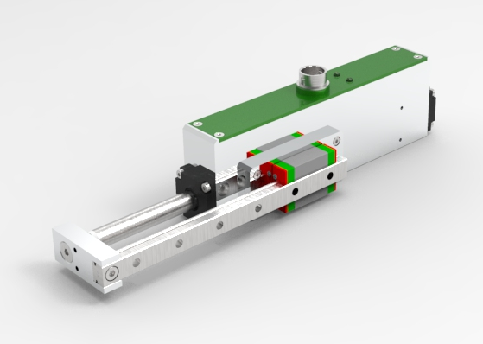
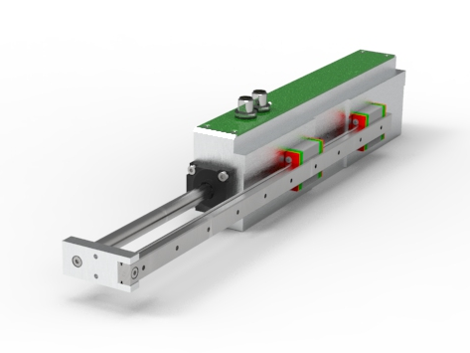

Magnetic spring for vertical application
In vertical applications, when the linear motor is not powered, the linear axis can fall down due to gravity. Using MagLift, the gravitational force is counterbalanced and the linear motor remains in steady state. 6 force sizes are available : 12, 17, 22, 40, 50 and 60 N, respectively MagLift12, MagLift17, MagLift22, MagLift40, MagLift50 and MagLift60.


