Adapter cable
Typically, an adapter cable is provided to connect the motor D-SUB9 connectors to the feedback port and the motor phase port on the target servo drive.
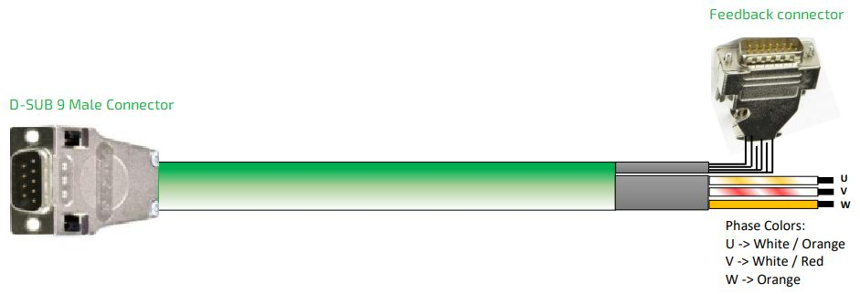adapter.jpg
Alternative color for the phases are: U→ , V → , W→
Servo drive type | TBS1 | Xtrapulspack | Servotronix CDH2
Adapter cable ordering code | DA002008 | DA002007 | DA002010
Standard lenghts are 3 and 5 meters. For example DA002008-5M (ordering code for 5 meter adapter cable)
Adapter cable pinout: https://www.nilab.at/download/da002007-da002008-adapter-cable/?wpdmdl=3045&refresh=637b84805bc981669039232

