Installation

Slider distance for parallel drive mounting
When the application needs tandem parallel configuration of the integrated drive linear motor, the two or more actuators must be mounted guaranteeing the safety distance L3 to avoid the interaction between the magnetic sliders.
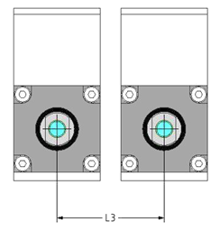
MOTOR MODEL | NO INTERACTION | MEDIUM INTERACTION | STRONG INTERACTION
NL040 | > 20 mm | > 15 mm to 20 mm | < 10 mm
NL080 | > 35 mm | > 15 mm to 35 mm | < 15 mm
NL120 | > 65 mm | > 45 mm to 65 mm | < 45 mm

NL040Q Fixing points
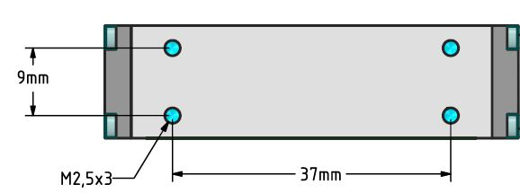nl40q_befest.jpg

NL040X Fixing points
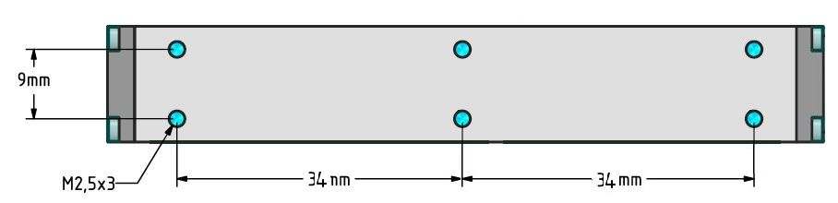nl40x_befest.jpg

NL080Q Fixing points
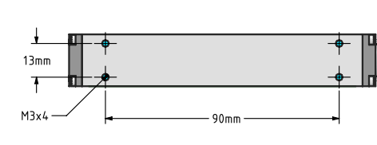

NL080X Fixing points
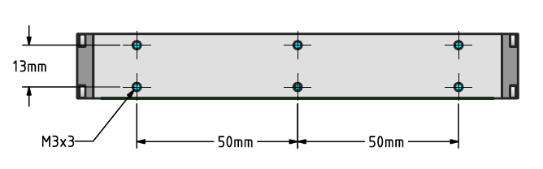

NL120Q Fixing points
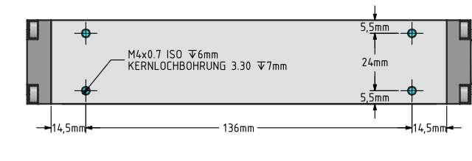

NL120X Fixing points
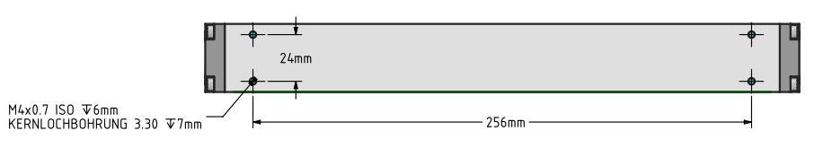

NL040Q/X slider fixing point
Slider has M2 threaded hole at each slider ends.
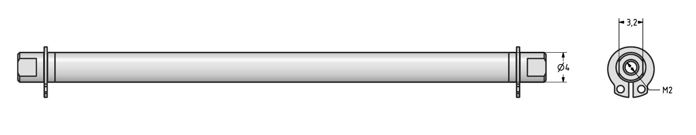nl040_rod_befest.jpg

NL080Q/X slider fixing point
Slider has M4 threaded hole at each slider ends.
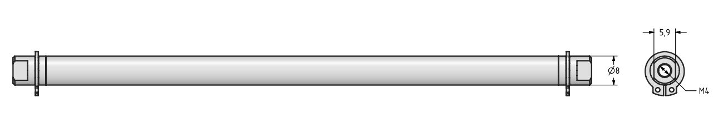slider_8.jpg

NL120QX slider fixing point
Slider has M4 threaded hole at each slider ends.
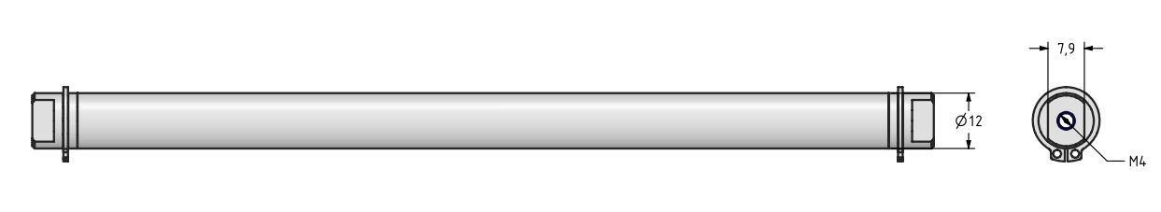slider_12.jpg

