Cables accessories
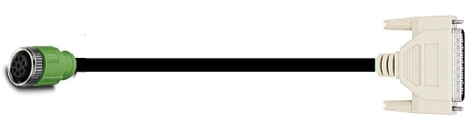da00012011.jpg
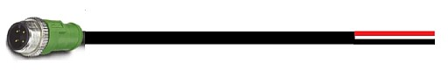da0022011.jpg
The power cable DA022012 terminates with 4 wires: 2 for +24VDC, 2 for GROUND.
The signal cable DA012012 is equipped with D-SUB15 female connector with the following pinout:
PIN | SIGNAL | DESCRIPTION
1 | RS485_A | Modbus A
2 | RS485_B | Modbus B
3 | GND | Ground
4 | CANH | Canbus H
5 | CANL | Canbus L
6 | CAN_TERM_L | CAN L termination resistance 120 Ohm
7 | CAN_TERM_H | CAN H termination resistance 120 ohm
8 | DIG_IN_1 | Digital Input 1 (24V logic)
9 | DIG_IN_2 | Digital Input 2 (24V logic)
10 | DIG_OUT_1 | Digital output 1 (24V logic, internal pull-up, NPN or PNP as default)
11 | DIG_OUT_2 | Digital output 2 (24V logic, internal pull-up, NPN or PNP as default)
12 | DIG_OUT_VCC | Digital Output Vcc
13 | DIG_OUT_GND | Digital Output Ground
14 | ANALOG1-IN1 | Analog Inpiut 1 - 0 to 10V programmable
15 | CONTROL SUPPLY | Control supply voltage from 10 to 80 VDC

Din rail modules
The signal cable with D-SUB15 connector can be combined with NL-DB15-MG6 DIN-RAIL terminal blocks to facilitate the installation of the motor.

