Electrical characteristics

Integrated drive capabilities
Parameter | Unit | Value
Rated Voltage | V | 24-48 VDC
Minimum voltage | V | 18 VDC
Maximum voltage admitted | V | 80 VDC
Boost current (5sec) | A | 120 A@5sec
Peak current | A | 100 A
Rated current (max) | A | 50 A
Rated output power (max) | A | 3.6 kW
PWM Frequency | kHz | 10

Control and peripheral
- 2 digital inputs (24V logic level)
- 2 analog input (0 to 10V)
- 1 canbus interface (DS402)
- 1 RS232 with MODBUS RTU protocol

Power supply
Phoenix Contact TRIO-PS-2G/3AC/24DC/40. 24 VDC output 40 Amp Power Supply 3-phase 320 -575 Vac input.
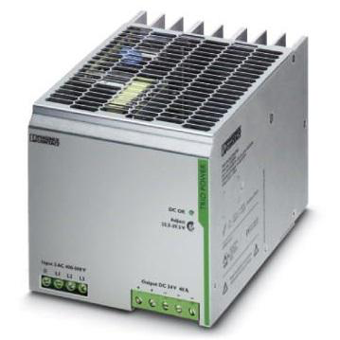
Omron S8JX-P Switch Mode DIN Rail Power Supply, 100 → 240V ac ac, dc Input, 12V dc dc Output, 53A Output, 600W
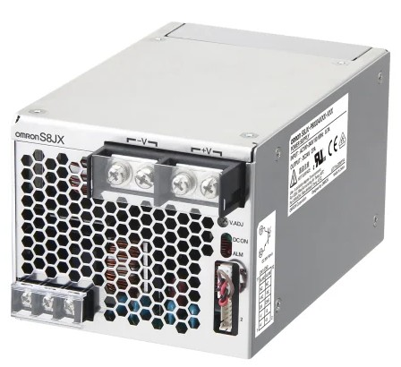omron_power.jpg

