Mechanical construction
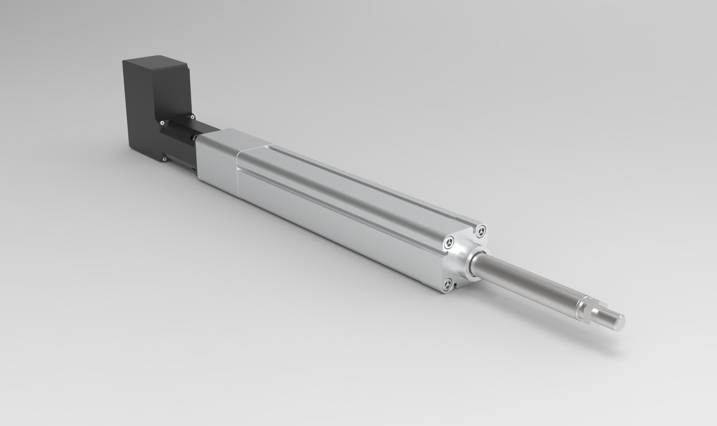
Standard: ISO 15552, Ball screw lead: 5, 10, 20 mm. The output screw is M16x1.5mm.
Ballscew actuator sizes | 50, 63
Standard | ISO15552
Repeatability (mm) | ±0.02
Ball screw lead (mm) | 5, 10, 20
Ball screw | 50: C7ø16  63: C7ø20
Stroke (mm) | 50: 100~600/50 pitch  63: 100~800/50 pitch
Antirotation accuracy | ±0.4 degrees
Max speed (mm/s) | 250~1000
Rated thrust (N) | 390~3000

