Programming software
In order to configure the integrated motor drive, please use the PC software called Motolab Starter: https://www.nilab.at/download/motolab_starter_ver0-0-1-0/?wpdmdl=6631&refresh=635638e9ee1601666595049
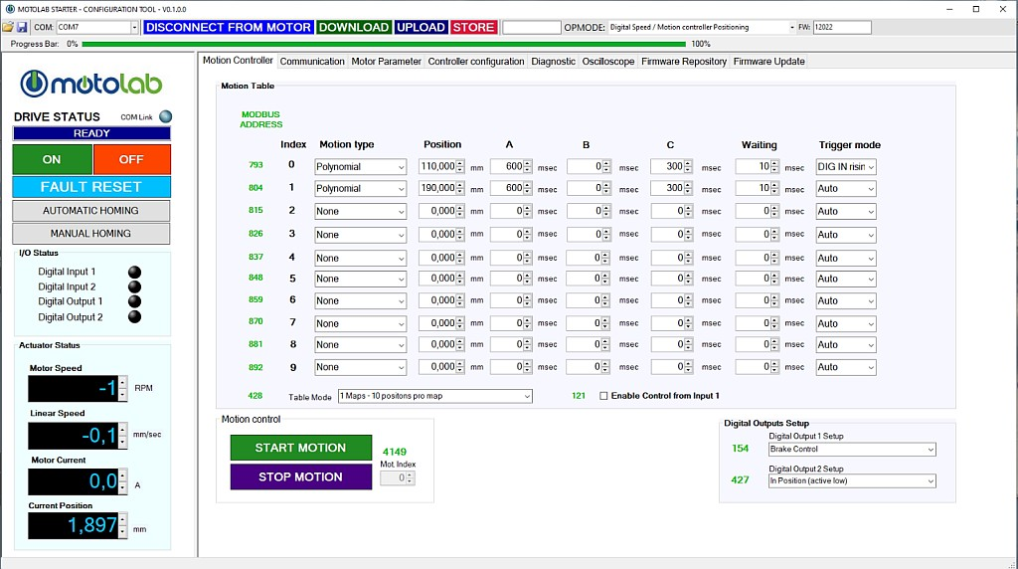motolab_starter_1.jpg
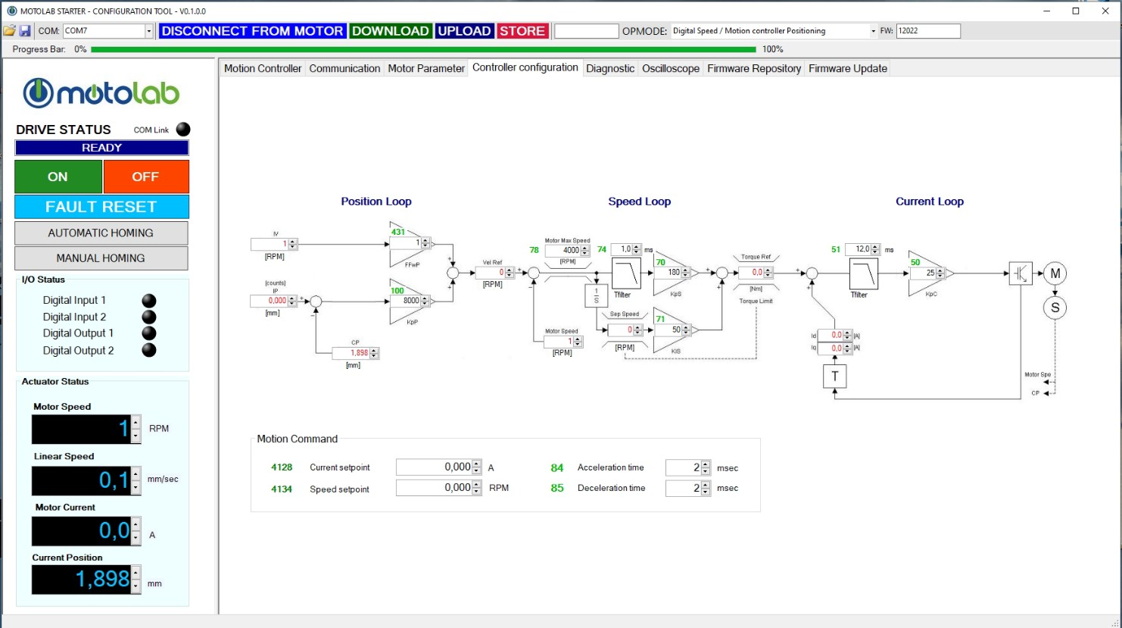motolab_starter_2.jpg
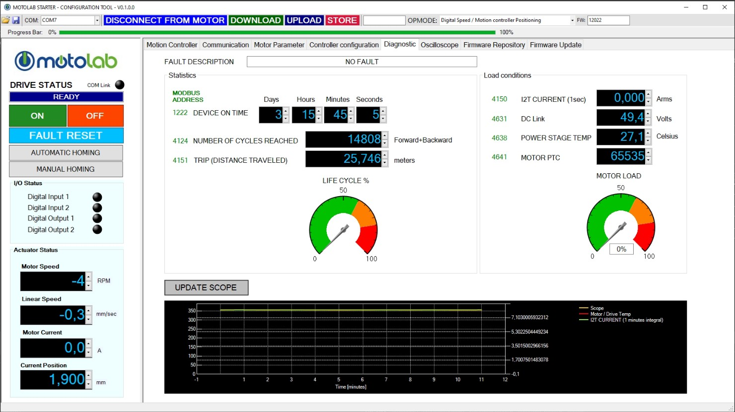motolab_starter_3.jpg

