NELA 24VDC linear actuator
NELA 24VDC are used in several industries, especially for industrial automation.
The compact tubular design integrating high efficient leadscrew transmission, durable brush motor and sandblasting aluminum alloy tube
makes everything simple and neat. Built-in over current detection (OCD) unit provides users with extra proactive safety measure.
It protects device from being damaged due to imprecise setup or any blockage on its way, therefore users save time and money for repair.
Advanced function such as stroke setting (S), reed switches (R) or hall effect sensor (H) are available for selection.
Accessories such as manual switch, remote controller, mounting bracket, control circuit board and power supply are optional.
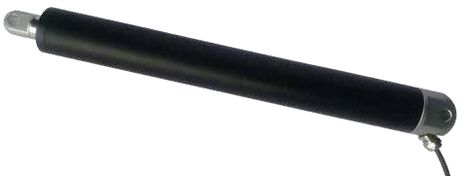

Specifications
Parameter | NELA35 | NELA45
Voltage | 24 / 12VDC | 24 / 12VDC
No Load Current | 0.2 / 0.35 A | 0.37 / 0.75 A
Operating temperature | -20 / + 60 °C | -20 / + 60 °C
Max Current | 2.5 / 5.0 A | 5.0 / 10 A
Max Force | 2000N | 6500N
Duty cycle | 20% | 20%
IP Grade | IP66 | IP66
Stroke | 100,200,300,400,500mm | 100,200,300,400,500mm
Built in | Patented OCD unit | Patented OCD unit
Certification | CE, RoHS | CE, RoHS

