Motor memory dump
Memory dump windows is used to save an load the content of the motor memory. All the modbus register from starting address 0 to address 1902.
The uPLC memory area is not downloaded using this memory dump window.
Pressing the button (1) - Donwload Data from motor and save to file, all the 1902 registers are read and store inside a file with .par extension.
Pressing the button (2) - Read file and download data to motor, the file is read and the 1902 registers are write inside the motor memory.
During download is the option (4) is checked the value inside the file is compared with the value inside the motor. If the value is the same, no write is performed.
If the value is different the value is stored inside the motor memory and the counter (5) of the changed register will increase.
If the option (3) is checked the window starter interface is updated with tthe new value uploading the new stored value from motor memory.
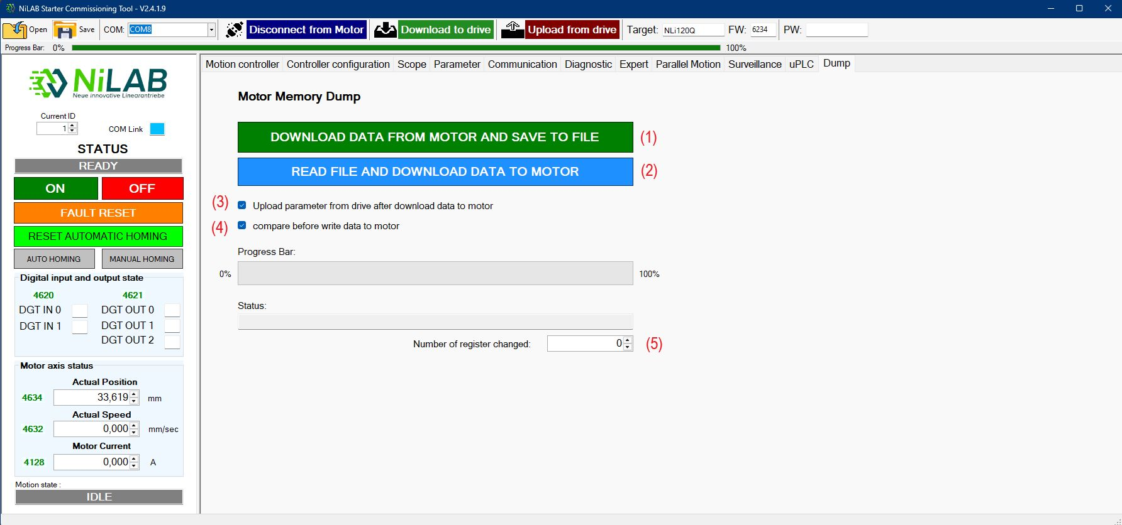dump_win.jpg
Please note that, to confirm the downloaded values you need to go to Paramter and press Write configuration to flash.

