Motion controller

Position table
The motion controller window is used to specify the motion sequences. It is based on 10 row tables. Every row configures the motion task with these parameters:
- Motion type: trapezoidal, triangular, polinomial, sinusoidal or force
- Target position
- Acceleration, deceleration and constant speed time depending on the motion profile used
- Waiting time
- Trigger mode: automatic, rising edge, falling edge, high and low level of trigger input (Digital input 1)
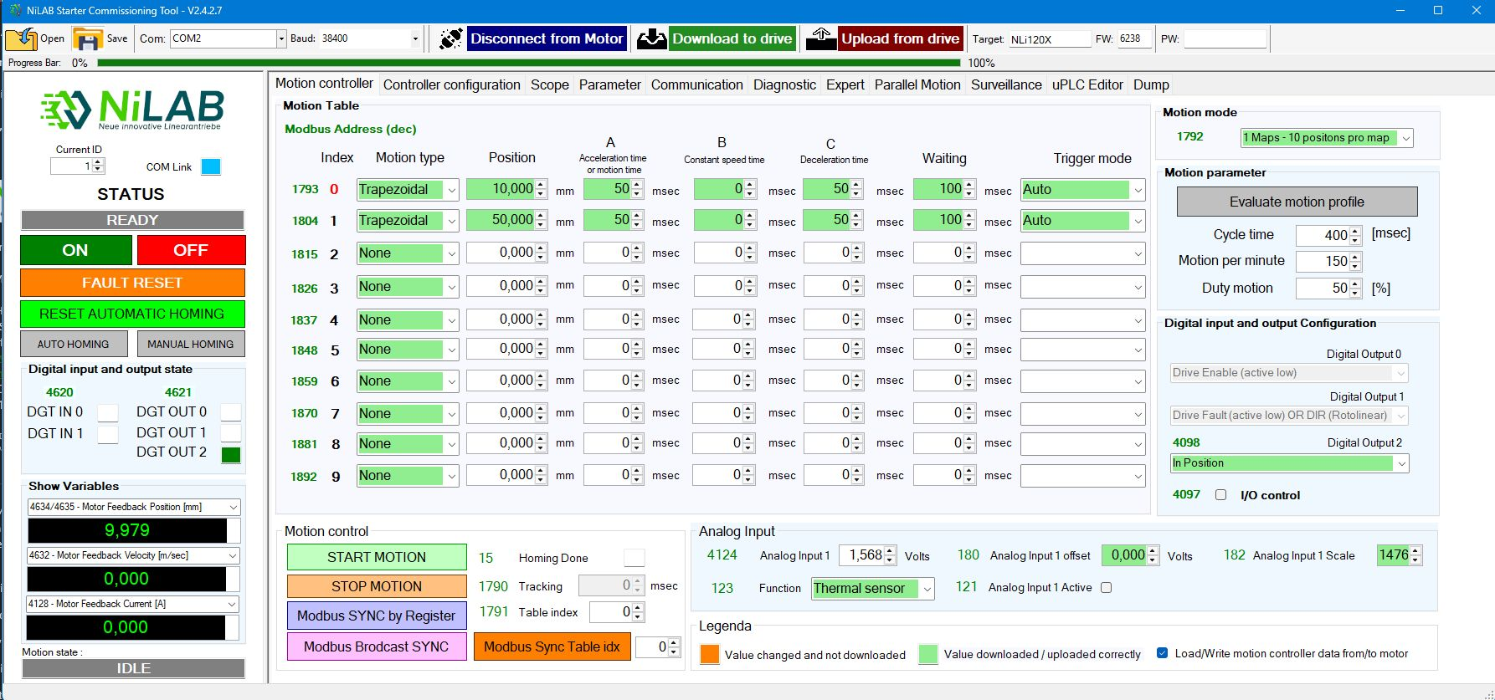moiton_screen_1.jpg
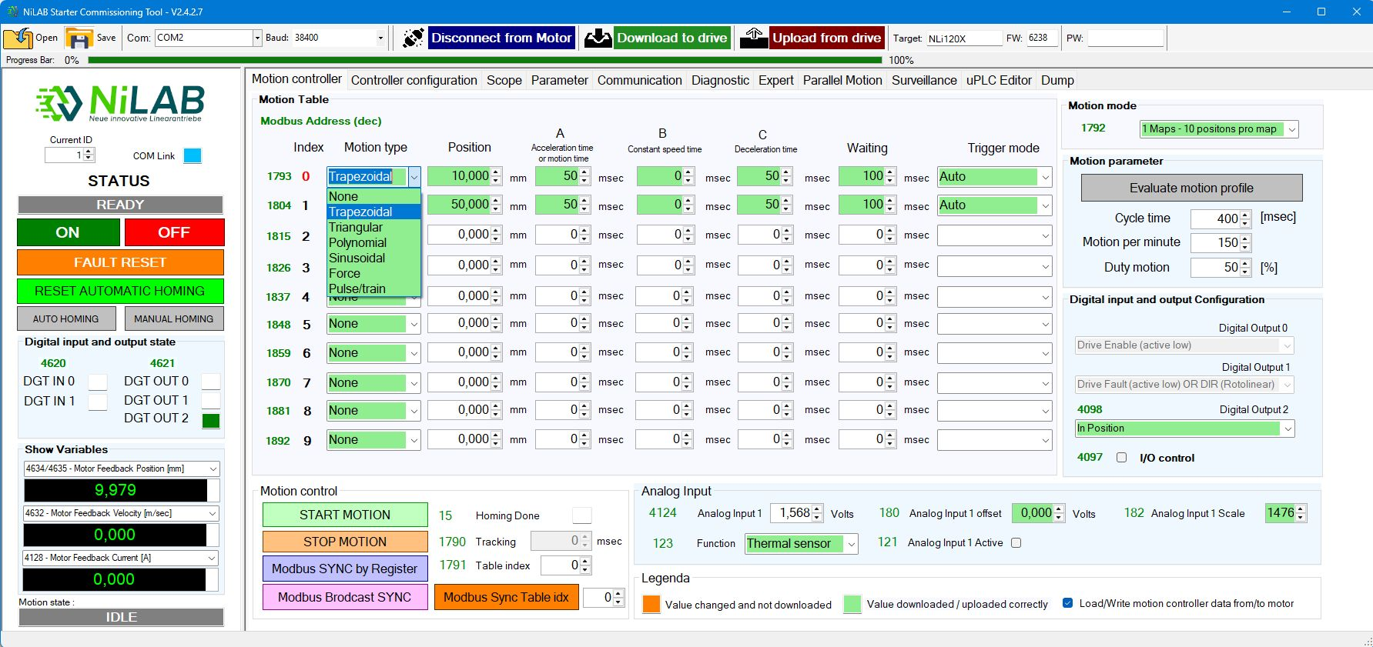motion_screen_2.jpg
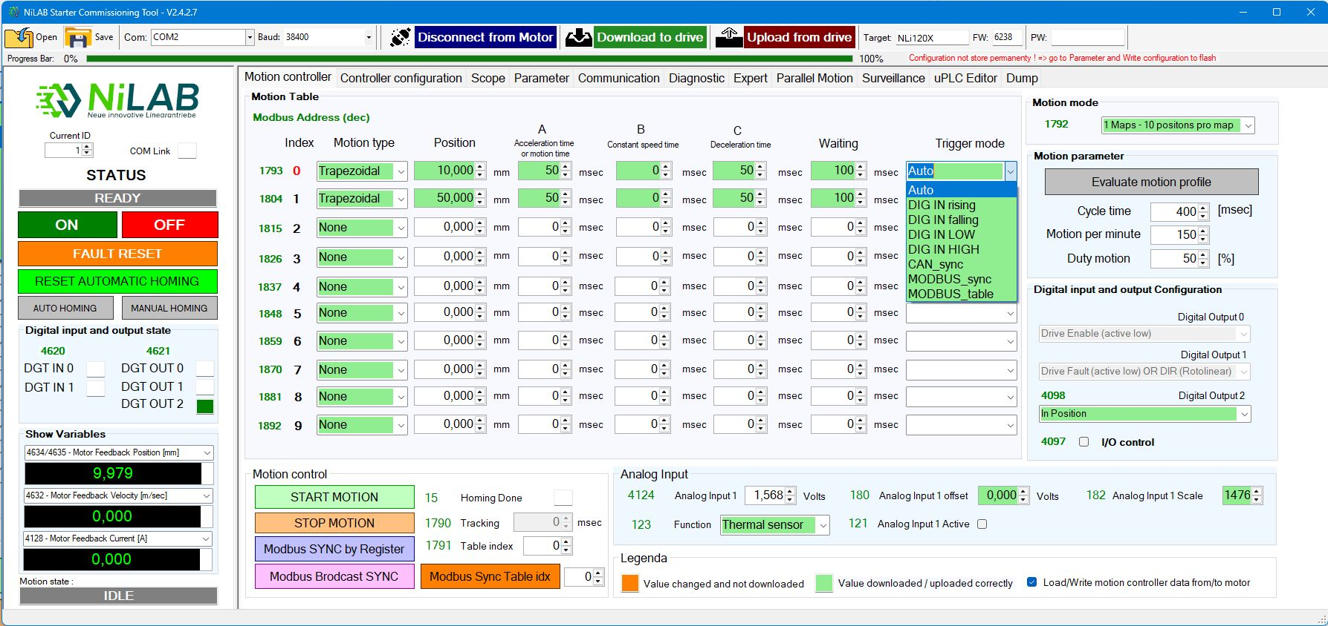motion_screen_3.jpg
PLEASE IN ORDER TO STORE PERMANENTLY THE CONFIGURATION - PRESS THE WRITE CONFIGURATION TO FLASH
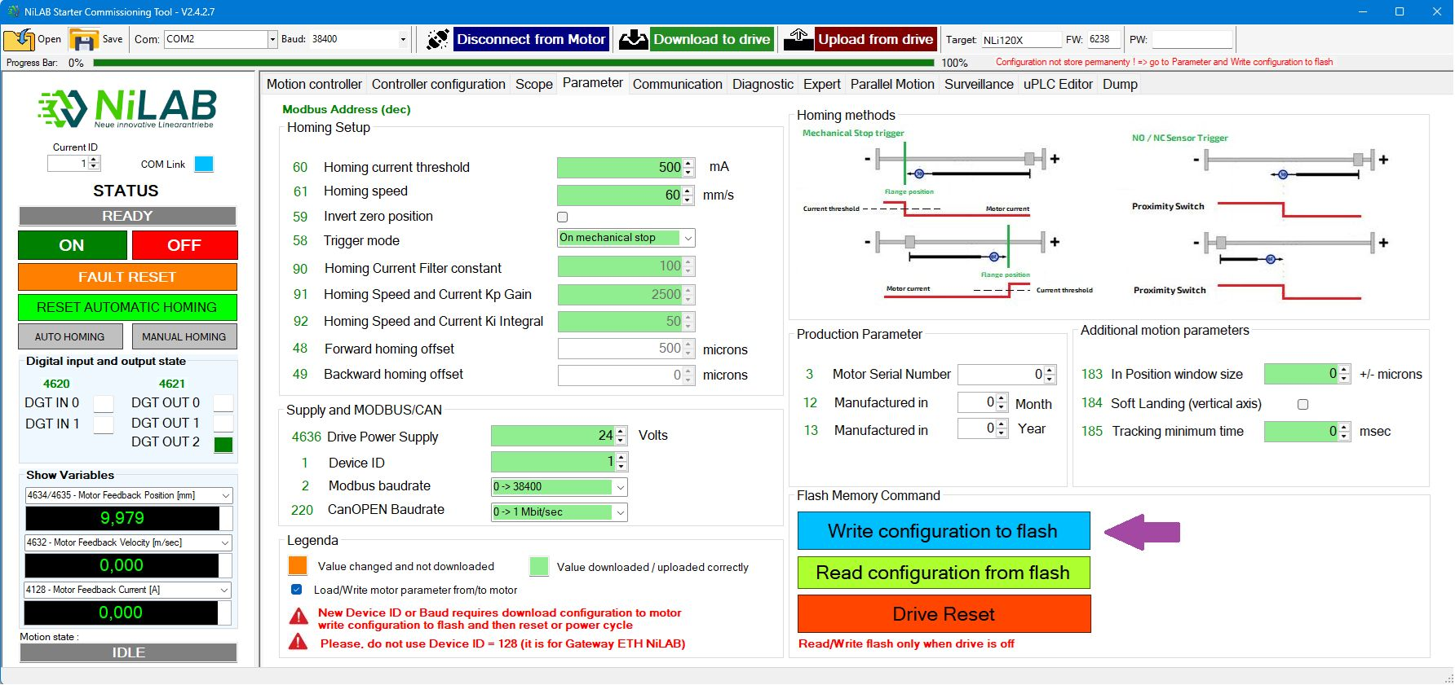motion_screen_4.jpg

