Starter Status Area
The left area of the NiLAB Starter is the motor status area window.
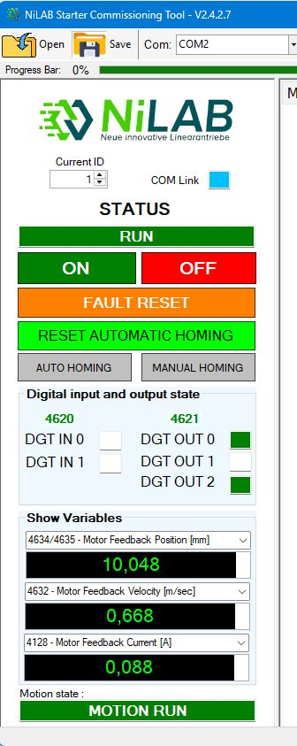status_screen.jpg | On the top of the list we have:  * Current ID ⇒ Modbus address. This can be changed in order to connect to different modbus nodes  * COM LInk LED shows the status and the speed of the serial communicaiton.  The STATUS text shows the current status of the motor. For example READY (Motor is switched-off and ready to be switched-on), RUN (motor switched on).  In the area below we have all the motor controls:  - ON - Motor power on  - OFF - Motor power off  - FAULT RESET - Reset the active fault  - RESET AUTOMATIC HOMING - Reset the homing flag to perform a new automatic homing  - AUTO HOMING - Automatic homing start  - MANUAL HOMING - Set the 0 axis on the current position of the motor slide  Digital input and output state section show the current status of the digital inputs and outputs.  Show variables are 3 configurable numeric variables with this options:  * 4096 - Axis Command Word  * 4608 - Axis Status Word  * 4634/4635 - Motor Feedback Position [mm]  * 4632 - Motor Feedback Velocity [m/sec]  * 4128 - Motor Feedback Current [A]  * 4130 - Motor Encoder Sin [Lsb]  * 4131 - Motor Encoder Cosin [Lsb]  * 4132 - Motor Encoder Arctan [Lsb]  * 4631 - Power Dcbus Voltage [V]  * 4630 - Power i2t Value  * 4129 - Power i2t 1sec  * 7 - Motor Drive Temperature [°C]  * 8/9 - Motor Number of Cycles Reached  * 10/11- Motor Trip Distance Traveled [m]  * 5/6 - Motor Drive on Time [sec]  * 4133/4134 - Control Position Target [mm]  * 4135 - Control Speed Target [m/sec]  * 4136 - Control Current Target [A]  The MOTION STATE shows the motion machine state value. For example MOTION RUN when the motor is moving, WAITING FOR TRIGGER if the motion controller is waiting for the trigger.

