Ports and connectors

NL7-EC F 230VAC Servo Drive
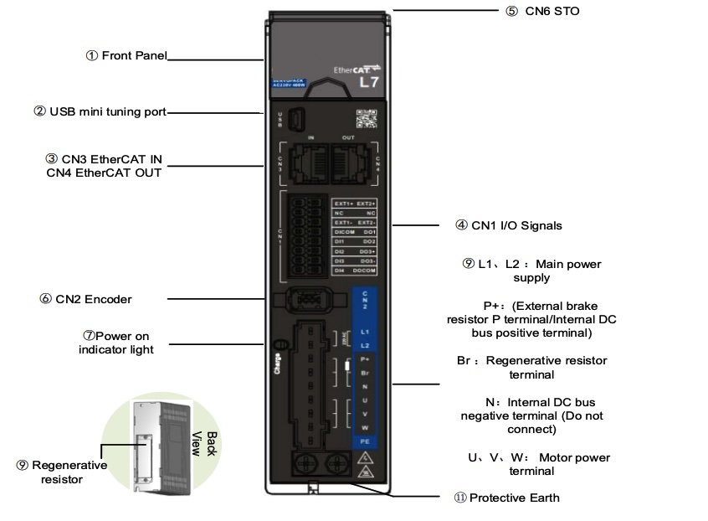conn_1.jpg

NL7-ECFT 400VAC Servo Drive


