Safe Torque Off (STO) Port - CN6
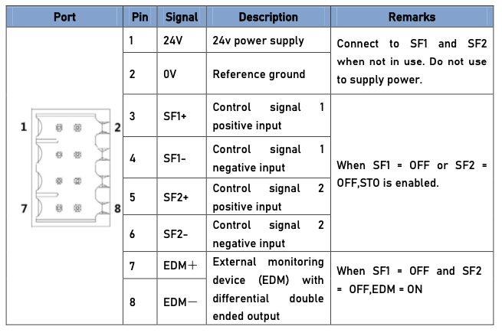sto_port.jpg
Function: Cut off motor current supply physically (through mechanical means) STO module (CN6 connector) consists of 2 input channels. It cuts off the motor current supply by blocking of PWM control signal from the power module. When the motor current is cut off, the motor will still move under inertia and stops gradually. The STO function is set up ready to be used by factory default. Please remove STO connector if it is not needed.

STO function principle
STO module cuts off the motor current supply and stops motor gradually by blocking of PWM control signal from the power module through 2 isolated circuits. When a STO error occurs, the actual status of STO can be determined by the EDM status feedback.
SF1 Input Status | SF2 Input Status | EDM Output Status | PWM contriol signal | Alarm code
ON | ON | OFF | Normal | -
ON | OFF | OFF | Blocked | Er 1c2
OFF | ON | OFF | Blocked | Er 1c1
OFF | OFF | ON | Blocked | Er 1c0

STO wiring diagram
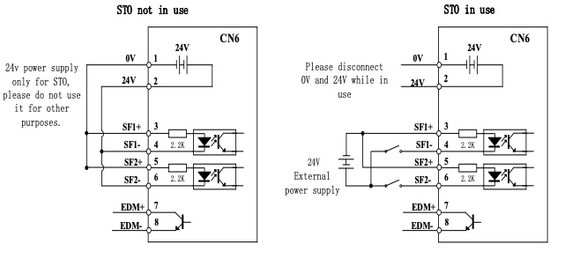sto_wiring.jpg
Please take precautions when enabling STO functions as servo drive will lose control over the motion of the motor. Motor might dropped under gravitational pull (vertically mounted load) or moved when external forces a re applied to it. Alternatively, motor with holding brake can be chosen.
- STO is not meant to cut off the power supply of the servo drivers and motors completely. Please power off and wait for a few minutes before starting maintenance work.
- It is recommende d to use an isolated power supply for STO signal input as any current leakage might cause STO malfunction.

