NL-EB15 Compact safety light curtain
EB15 safety light curtain has a unique structure - emitting light surface is 15mm compact size, light is emitted from side. Multiple output signal, easy installation and cable connection. Meanwhile, quick response time to ensure reliable performance.
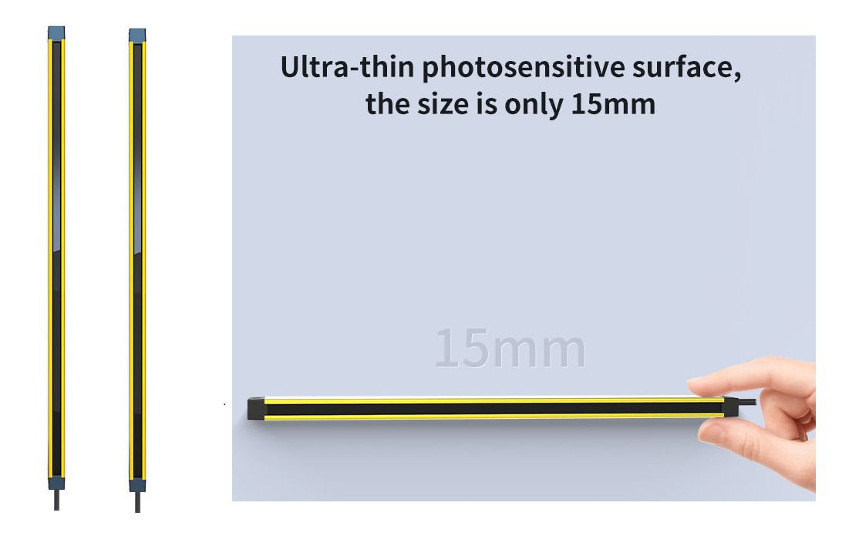main_2.jpg

Product feature
- Ultra-thin photosensitive surface, the size is only 15mm
- Quick response, the fastest response time < 1msec.
- Low wide voltage power supply, the working voltage is 10 to 30VDC.
- Good performance to resist electromagnetic interference, and resist influence by electromagnetic of various equipment motors.
- Wire synchronization technology to resist light interference effectively.
- Easy to install cause of fixed end-cover.
- The section size is 39x15mm

What is provided with the Safety curtain ?
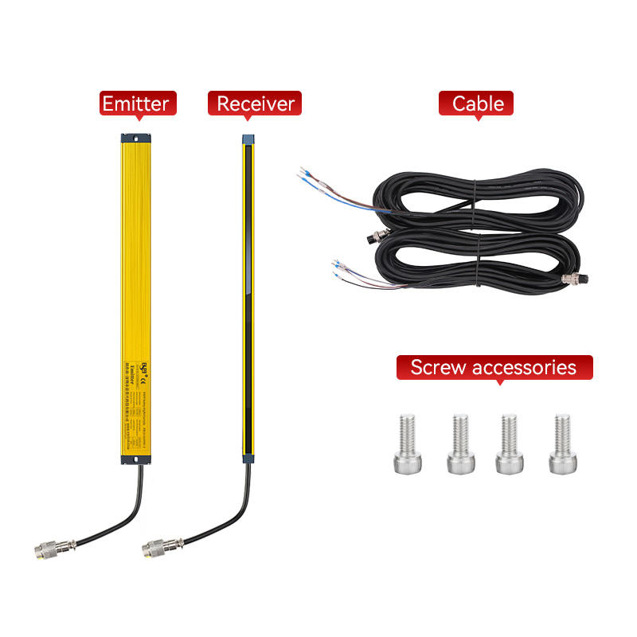main-07.jpg

