NLi-EtherCAT integrated linear motors
The NLi EtherCAT series includes a low voltage servo-drive with a power-supply of 24/48 VDC and is programmable using a serial connection and a Modbus RTU protocol. The motor can be controlled by interpolation using EtherCAT fieldbus.
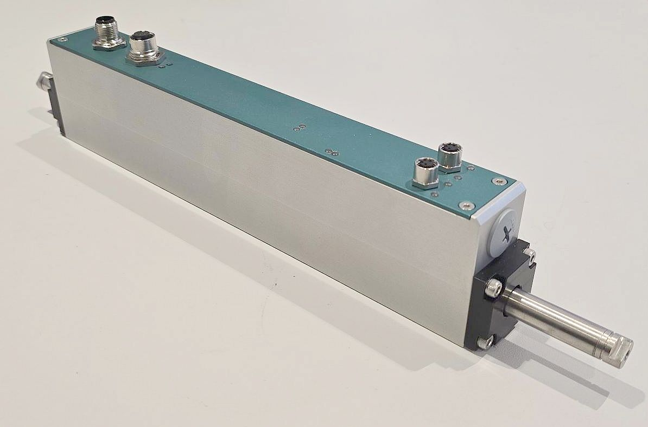nli120x_ethercat.jpg

Features:
- High performance linear motor with integrated drive
- Extremely compact form factor
- Highly dynamic
- Suitable for daisy-chain connections
- Low cabling effort

Video demostration

