Mechanical Dimensions
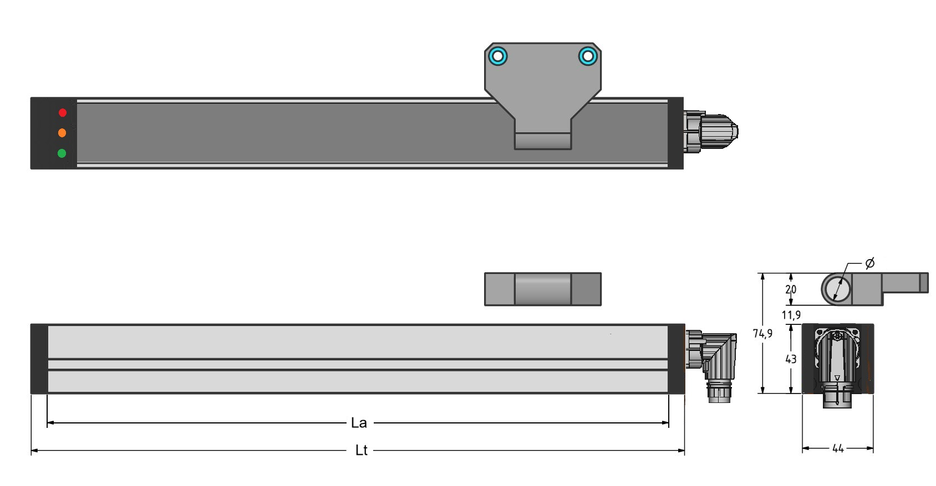encoder_view.jpg
Encoder Model | La | Lt
Revenc_736 | 736 | 856
Revenc_660 | 660 | 780
La is the Active Encoder Area where the sensor detect the position of the reference magnet.
Lt is the total length of encoder excluding the connector.

LED indicators
Condition | LED Green | LED Orange | LED Red
Normal operation | Dimming | - | -
Normal operation communicating with Hiperface RS485 interface | Dimming | Blinking | -
Encoder fault (SIN/COS under-range) | Dimming | - | ON
Boot phase (LED cycling) - duration from Reset 5 seconds | ON → OFF | ON → OFF | ON → OFF
Calibration active | Dimming | Blinking | -

3D step models
Revend_736: :reverso_encoder:revenc_encoder_-_profile_736mm.zip

