Mounting example
Here an mounting example in combination with L075P-6015 primary part with L075S reduced weight magnet (L=192mm).
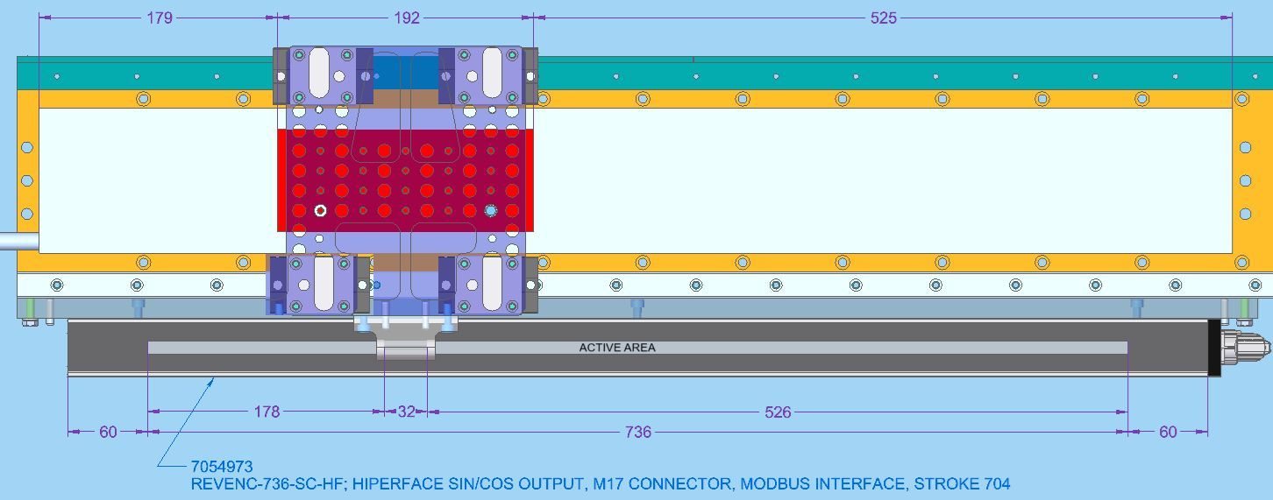mounting_example.jpg

