Reverso Encoder
RevEnc is an innovative encoder based on magnetic field detection of a reference magnet. The reference magnet moves over an active area composed by a magnetic hall sensors array.
The position of the reference magnet is detected in relative and absolute ways. The corresponding output signals are: SIN/COS 1 VPP analogue output and absolute information using Hiperface serial interface or DSL compatible with Sick protocol.
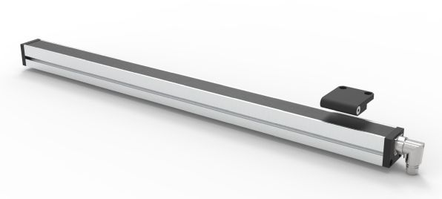revenc.jpg
The mounting distance between the reference magnet and the detecting region is not critical, from 5 to 20mm. The encoder is tunable and programmable using PC software.
The output resolution and the information regarding the electronic datasheet are stored inside the encoder memory.
RevEnc is particularly indicated to be used in combination with NiLAB’s R series linear motors. It allows to realize high-performance linear-axes without cables in movement.

