Technical Data
Parameter | Value | Unit | Comment
SIN/COS 1Vpp period | 32 / 16 / 8 / 4 / 2 | mm | Programmable with MODBUS interface
Resolution of absolute position | 1000 / 500 / 250 / 125 / 62,5 | microns | Depending on the SIN/COS period
Repeatability | +/-15.6 / 7.8 / 3.9 / 1.9 / 0.97 | microns | with a resolution of 12bit ADC on the drive side
Absolute accuracy | +/-156 / 78 / 39 / 19 / 9.7 | microns
Absolute position | 5 | bits | Hiperface decoding
Current consumption | 0,6 | Amps
Power supply | 24VDC | VDC | 11V min, 24VDC nominal, 48V max

SIN/COS Output type
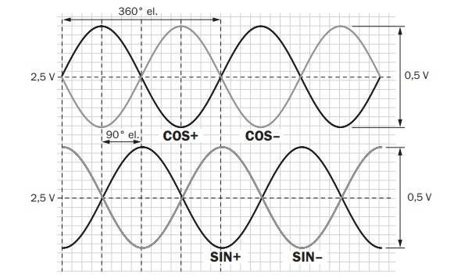sin_cos.jpg


