Power cable
The linear stage is equipped with 1 meter cable with M23 standard speedtec connector at the cable end.
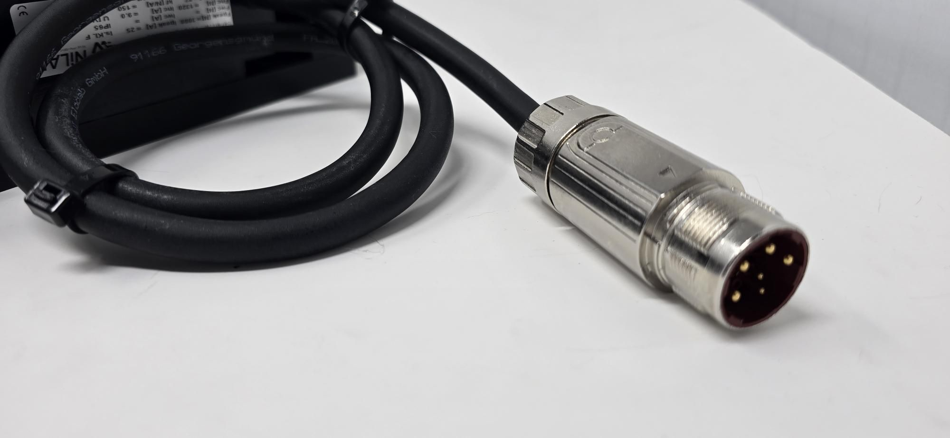power_cable.jpg

Pinout - Power connector BKUA145NN00420200400 (Serie 923 - 9 poles)
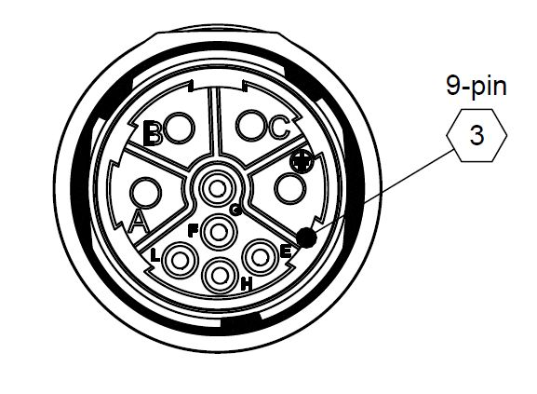
PIN | Signal
A | U phase
B | V phase
C | W phase
D/PE | Protection Earth
F | Thermal switch+
G | Thermal switch-
L | not connected
H | not connected
CASE | Shield

