Safety instruction

Introduction
Read these instructions before the initial startup of the equipment in order to eliminate the risk of bodily harm or material damage. Follow these safety instructions at all times.
Do not attempt to install or start up this equipment without first reading all documentation provided with the product. Read and understand these safety instructions and all user documentation of the equipment prior to working with the equipment at any time. If you do not have the user documentation for your equipment, contact a NiLAB representative to send this documentation immediately to the person or persons responsible for the safe operation of this equipment.
If the equipment is resold, rented or transferred or passed on to others, then these safety instructions must be delivered with the equipment.
warning_symbol.jpg
Improper use of this equipment, failure to follow the safety instructions in this document or tampering with the product, including disabling of safety devices, may result in material damage, bodily harm, electric shock or even death!

Explanation
The safety instructions describe the following degrees of hazard seriousness in compliance with ANSI Z535. The degree of hazard seriousness informs about the consequences resulting from noncompliance with the safety instructions.
Warning symbol with signal word | Degree of hazard seriousness according to ANSI
danger_symbol.jpg | Death or severe bodily harm will occur.
warning_symbol.jpg | Death or severe bodily harm will occur.
caution_symbol.jpg | Bodily harm or material damage may occur.
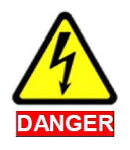danger_e_symbol.jpg | High voltage and high discharge current!  Danger to life or severe bodily harm by electric shock!
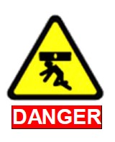danger_p_symbol.jpg | Dangerous movements! Danger to life, severe bodily harm or material damage by unintentional motor movements!
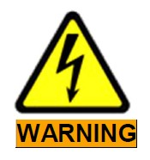warning_e_symbol.jpg | High electrical voltage due to wrong connections! Danger to life or bodily harm by electric shock!
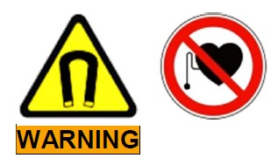warning_pace_symbol.jpg | Health hazard for persons with heart pacemakers, metal implants and hearing aids in proximity to electrical equipment!
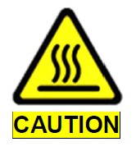caution_hot.jpg | Surface of machine housing could be extremely hot! Danger of injury! Danger of burns!
caution_hand.jpg | Risk of injury due to improper handling! Bodily harm caused by crushing, shearing, cutting and mechanical shock!

General Information
- NiLAB GmbH is not liable for damages resulting from failure to observe the warnings provided in this documentation.
- Read the operating, maintenance and safety instructions in your language before starting up the machine. If you find that you cannot completely understand the documentation for your product, please ask your supplier to clarify.
- Proper and correct transport, storage, assembly and installation as well as care in operation and maintenance are prerequisites for optimal and safe operation of this equipment.
- Only persons who are trained and qualified for the use and operation of the equipment may work on this equipment or within its proximity.
- The persons are qualified if they have sufficient knowledge of the assembly, installation and operation of the equipment as well as an understanding of all warnings and precautionary measures noted in these instructions.
- Furthermore, they must be trained, instructed and qualified to switch electrical circuits and equipment on and off in accordance with technical safety regulations, to ground them and to mark them according to the requirements of safe work practices. They must have adequate safety equipment and be trained in first aid.
- Only use spare parts and accessories approved by the manufacturer.
- Follow all safety regulations and requirements for the specific application as practiced in the country of use.
- The equipment is designed for installation in industrial machinery.
- The ambient conditions given in the product documentation must be observed.
- Use only safety features and applications that are clearly and explicitly approved in the User Manual.
- For example, the following areas of use are not permitted: construction cranes, elevators used for people or freight, devices and vehicles to transport people, medical applications, refinery plants, transport of hazardous goods, nuclear applications, applications sensitive to high frequency, mining, food processing, control of protection equipment (also in a machine).
- The information given in the documentation of the product with regard to the use of the delivered components contains only examples of applications and suggestions. The machine and installation manufacturer must to make sure that the delivered components are suited for his individual application and check the information given in this documentation with regard to the use of the components, to make sure that his application complies with the applicable safety regulations and standards and carry out the required measures, modifications and complements.
- Startup of the delivered components is only permitted once it is sure that the machine or installationin which they are installed complies with the national regulations, safety specifications and standards of the application. Operation is only permitted if the national LVD regulations for the application are met. The machine or installation manufacturer is responsible for compliance with the limiting values as
- prescribed in the national regulations.
- Technical data, connections and operational conditions are specified in the product documentation and must be followed at all times.

