MCSS Slide Units
MCSS slide unit are complete acutator based on integrated miniature tubular linear motors.
The slide table MCSS is a precision slide table integrated with guides and rails to isolate the load bearing from the movement of the dual slider linear motors. Integrated drive with encoder feedback ensures precise positioning. The magnet sprine Maglift accessories from NiLAB avoid dropping of the slide table when the motor is switched off.
Slide table cylinder working principle is that the parallel drive of two miniature tubular linear motors create the linear motion, and the stroke of the pushing depends on the length of the guide rail. According to the size of the force required for the work to determine the thrust and pull force on the guide rod. Generally used in printing, semiconductor, automation control, robotics and other industries.
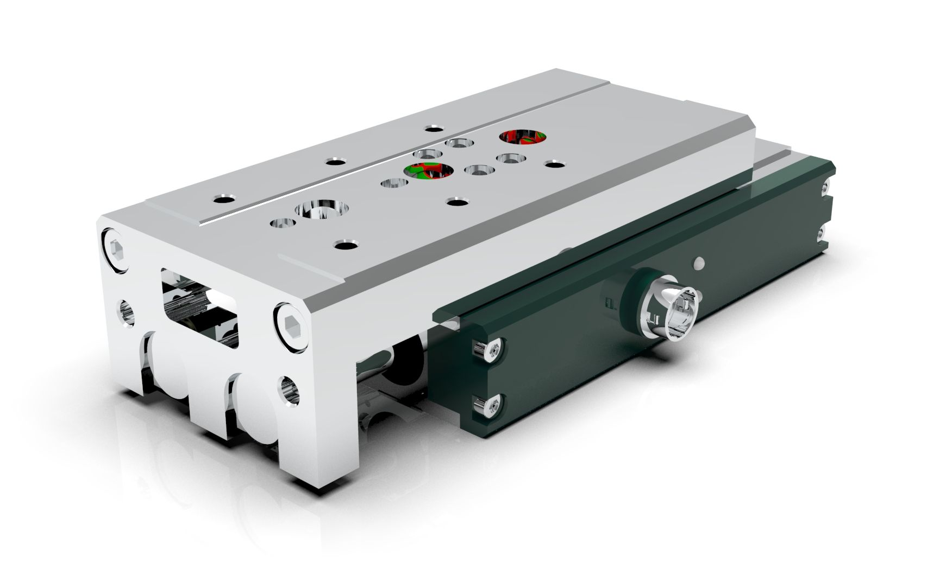mcss_photo.jpg

Features
- High precision combination of miniature tubular linear motors, servo drive, PLC and linear rail
- Flush fitting sensor groove
- Provide optional combination for stroke, compactness e dynamic motion
- High speed thanks to linear motor technology
- Plug and play thanks to integrated drive technology

