Ordering code
Type | Model | Size |  | Number o f carriages | Carriage length | Ltot | Reduce Position | Reducer type | Reducer position | End flange type
ULC | O - Orizontal / V - Vertical | 44 / 66 / 88 / 132 | N | 1 / 2 | mm | mm | mm | VSF / EPD / EPZ | 1 / 2 / 3 / 4 | Fc / Ff / As / Pr

Reducer position
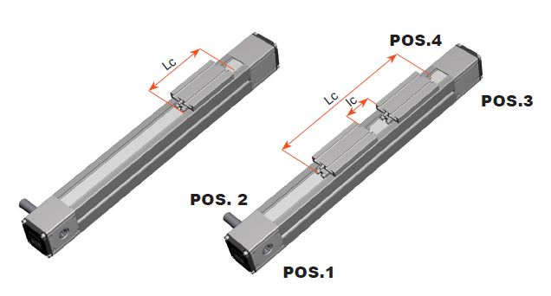positions.jpg

End flange type
Fc - Closed flange | Ff - Flange with hole | As - with shaft | Pr - Reducer option
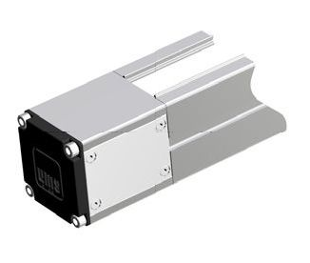fc_close.jpg | 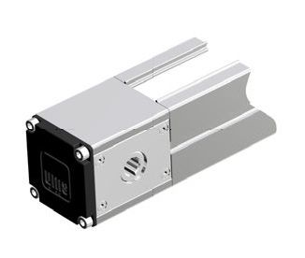ff_forata.jpg | 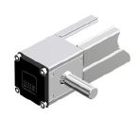as_shaft.jpg | 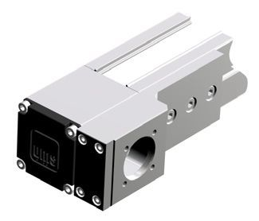pr_reducer.jpg

Example of code
ULCO-66-N-2-530-1200-1970-3-EPZ-1FC-2FC-4AS

