ULCO 44/66/88/132 - Belt driven linear units
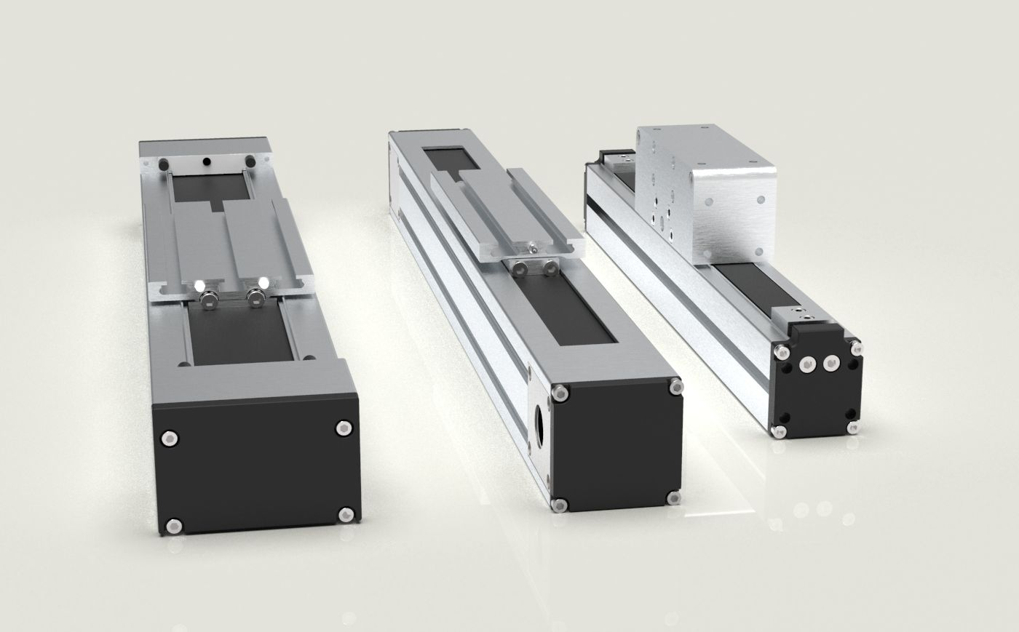ulco_family.jpg
ULCO linear units (available in 44/66/88/132 sizes) offer a complete modular system engineered to deliver high-performance movements on one or multiple axes. They're the ideal choice for simplifying the design and implementation of small to medium-power industrial automation. The modular design and careful study of the aluminum profile's cross-section give the system exceptional mechanical strength, making it self-supporting and easy to integrate. The main profile features unified T-slots (compatible with M5, M6, M8 nuts), allowing for quick integrations and customizations based on specific needs.
By appropriately combining the profile dimensions, drive type and guide type, ULCO units enable the optimization of several key performance aspects, including:
• Load capacity
• Speed and acceleration
• Travel and positioning precision
• Quiet operation
• Resistance to bending and torsion
• System inertia
• Durability and maintenance intervals
• Maximum stroke
• System efficiency
The standardization of components, coupled with strict quality and reliability criteria, ensures rational assembly, fast deliveries, timely technical support, and the availability of a highly competitive system on the market.

