ULCO 44
Performance in a small size, ideal for small power application with limited space. Good load rating.
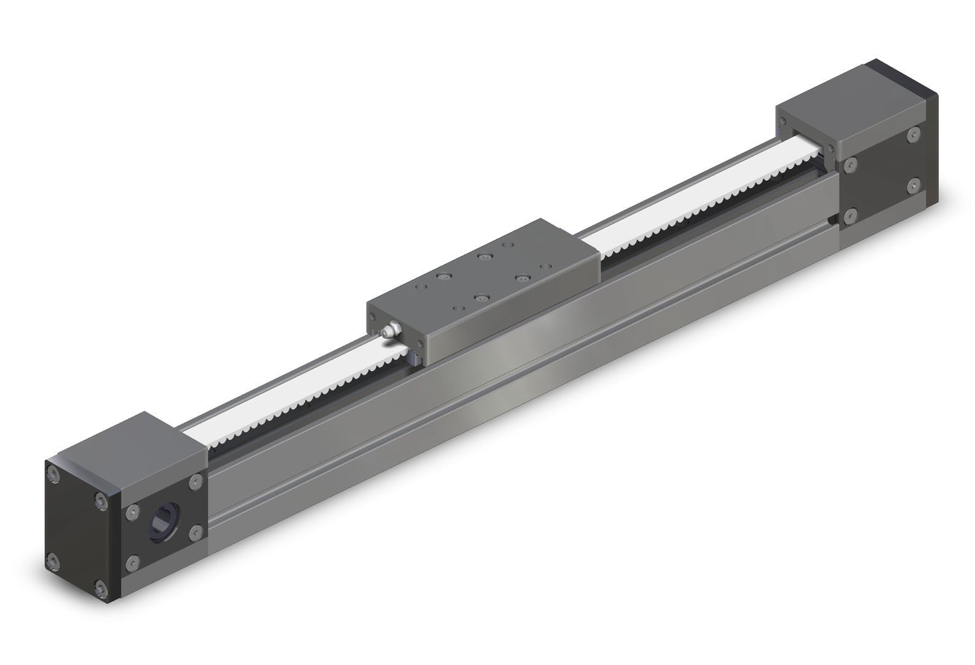ulco44.jpg

Mechanical Drawing
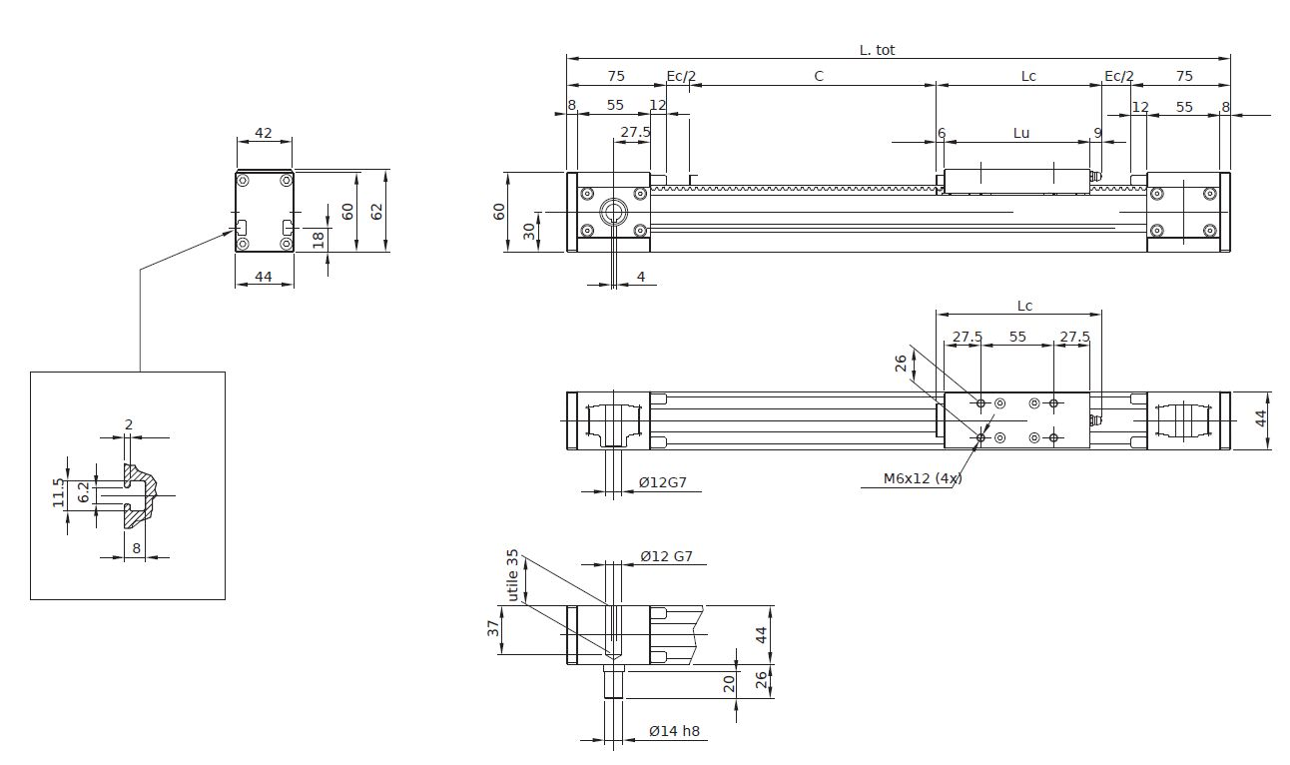ulco44_drw.jpg

Load rating
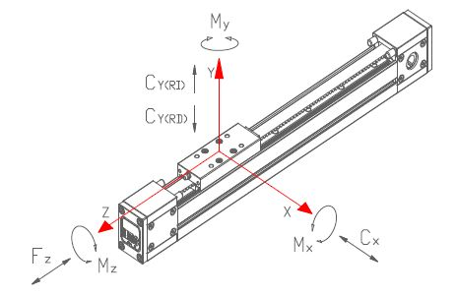ulco44_forces.jpg
ulco44_rating.jpg

Technical data
Parameter | Symbol | Value | Unit
Max usable stroke |  | 6500 | mm
Total lenght | Ltot | C+Lc+210 | mm
Carriage length | Lc | 125 | mm
Carriage usable length | Lu | 110 | mm
Extra-stroke (safety) | Ec | 60 | mm
Max speed |  | 250 | m/min
Max acceleration |  | 100 | m/sec2
Position repeatability |  | < 0.05 | mm
Aluminium profile section |  | 44 x 43 | mm
Inertia momentum of aluminium profile | Ix | 93110 | mm4
Inertia momentum of aluminium profile | Iy | 162710 | mm4
Type of mechanic |  | linear guide with compact block
Belt type |  | Poliuretan HTD-5M-17
Pulley teeth number |  | 24
Diameter |  | 38,2 | mm
Linear movement per rotation |  | 120 | mm
Operating temperature |  | -20 / +60 | degrees

